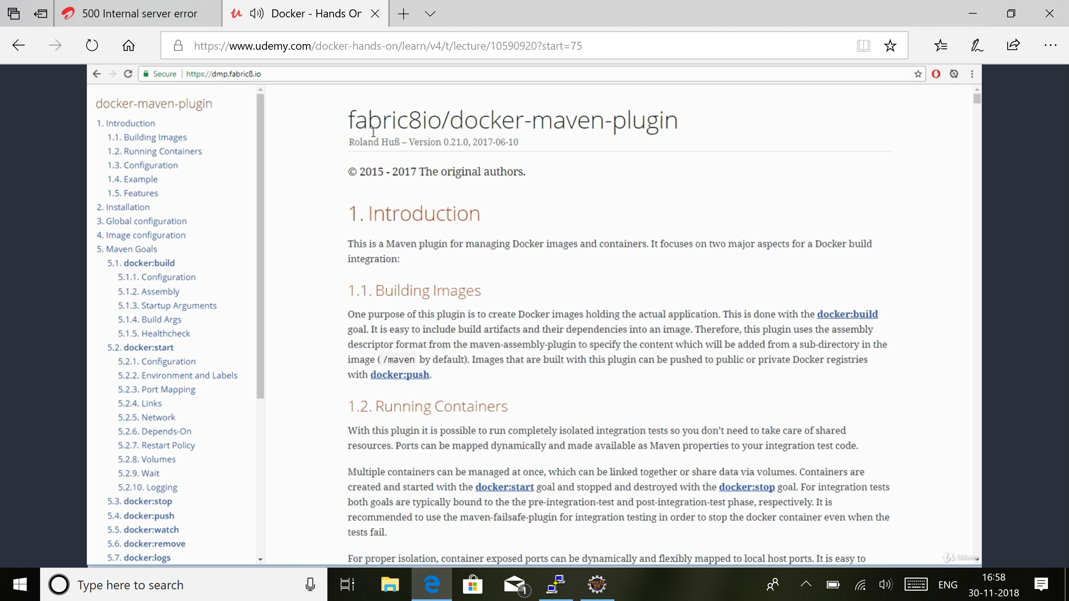

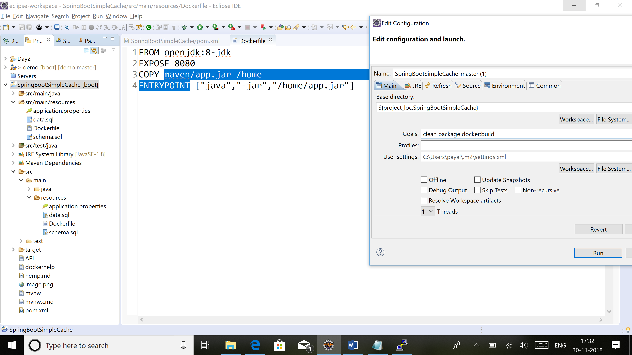

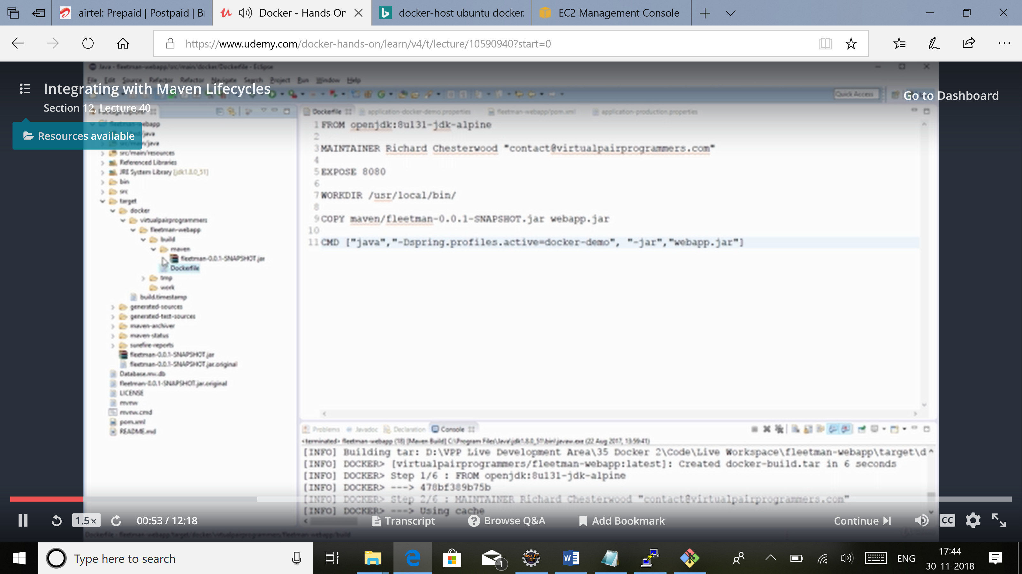

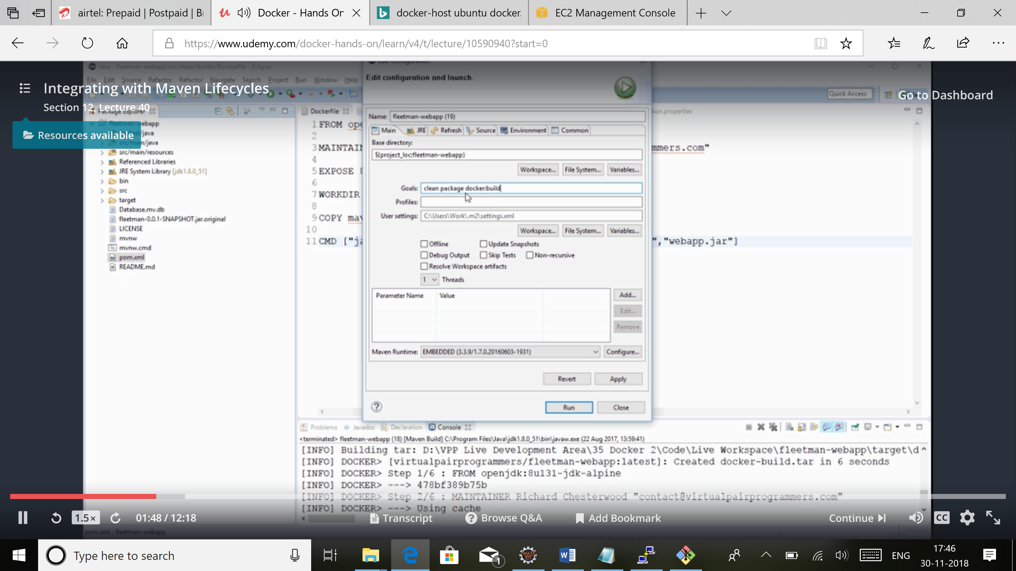

Phase: part of maven lifecycle

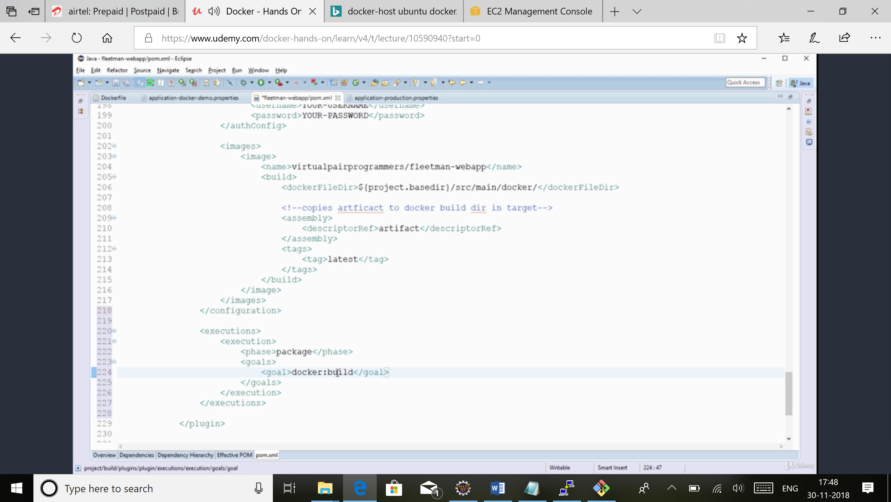

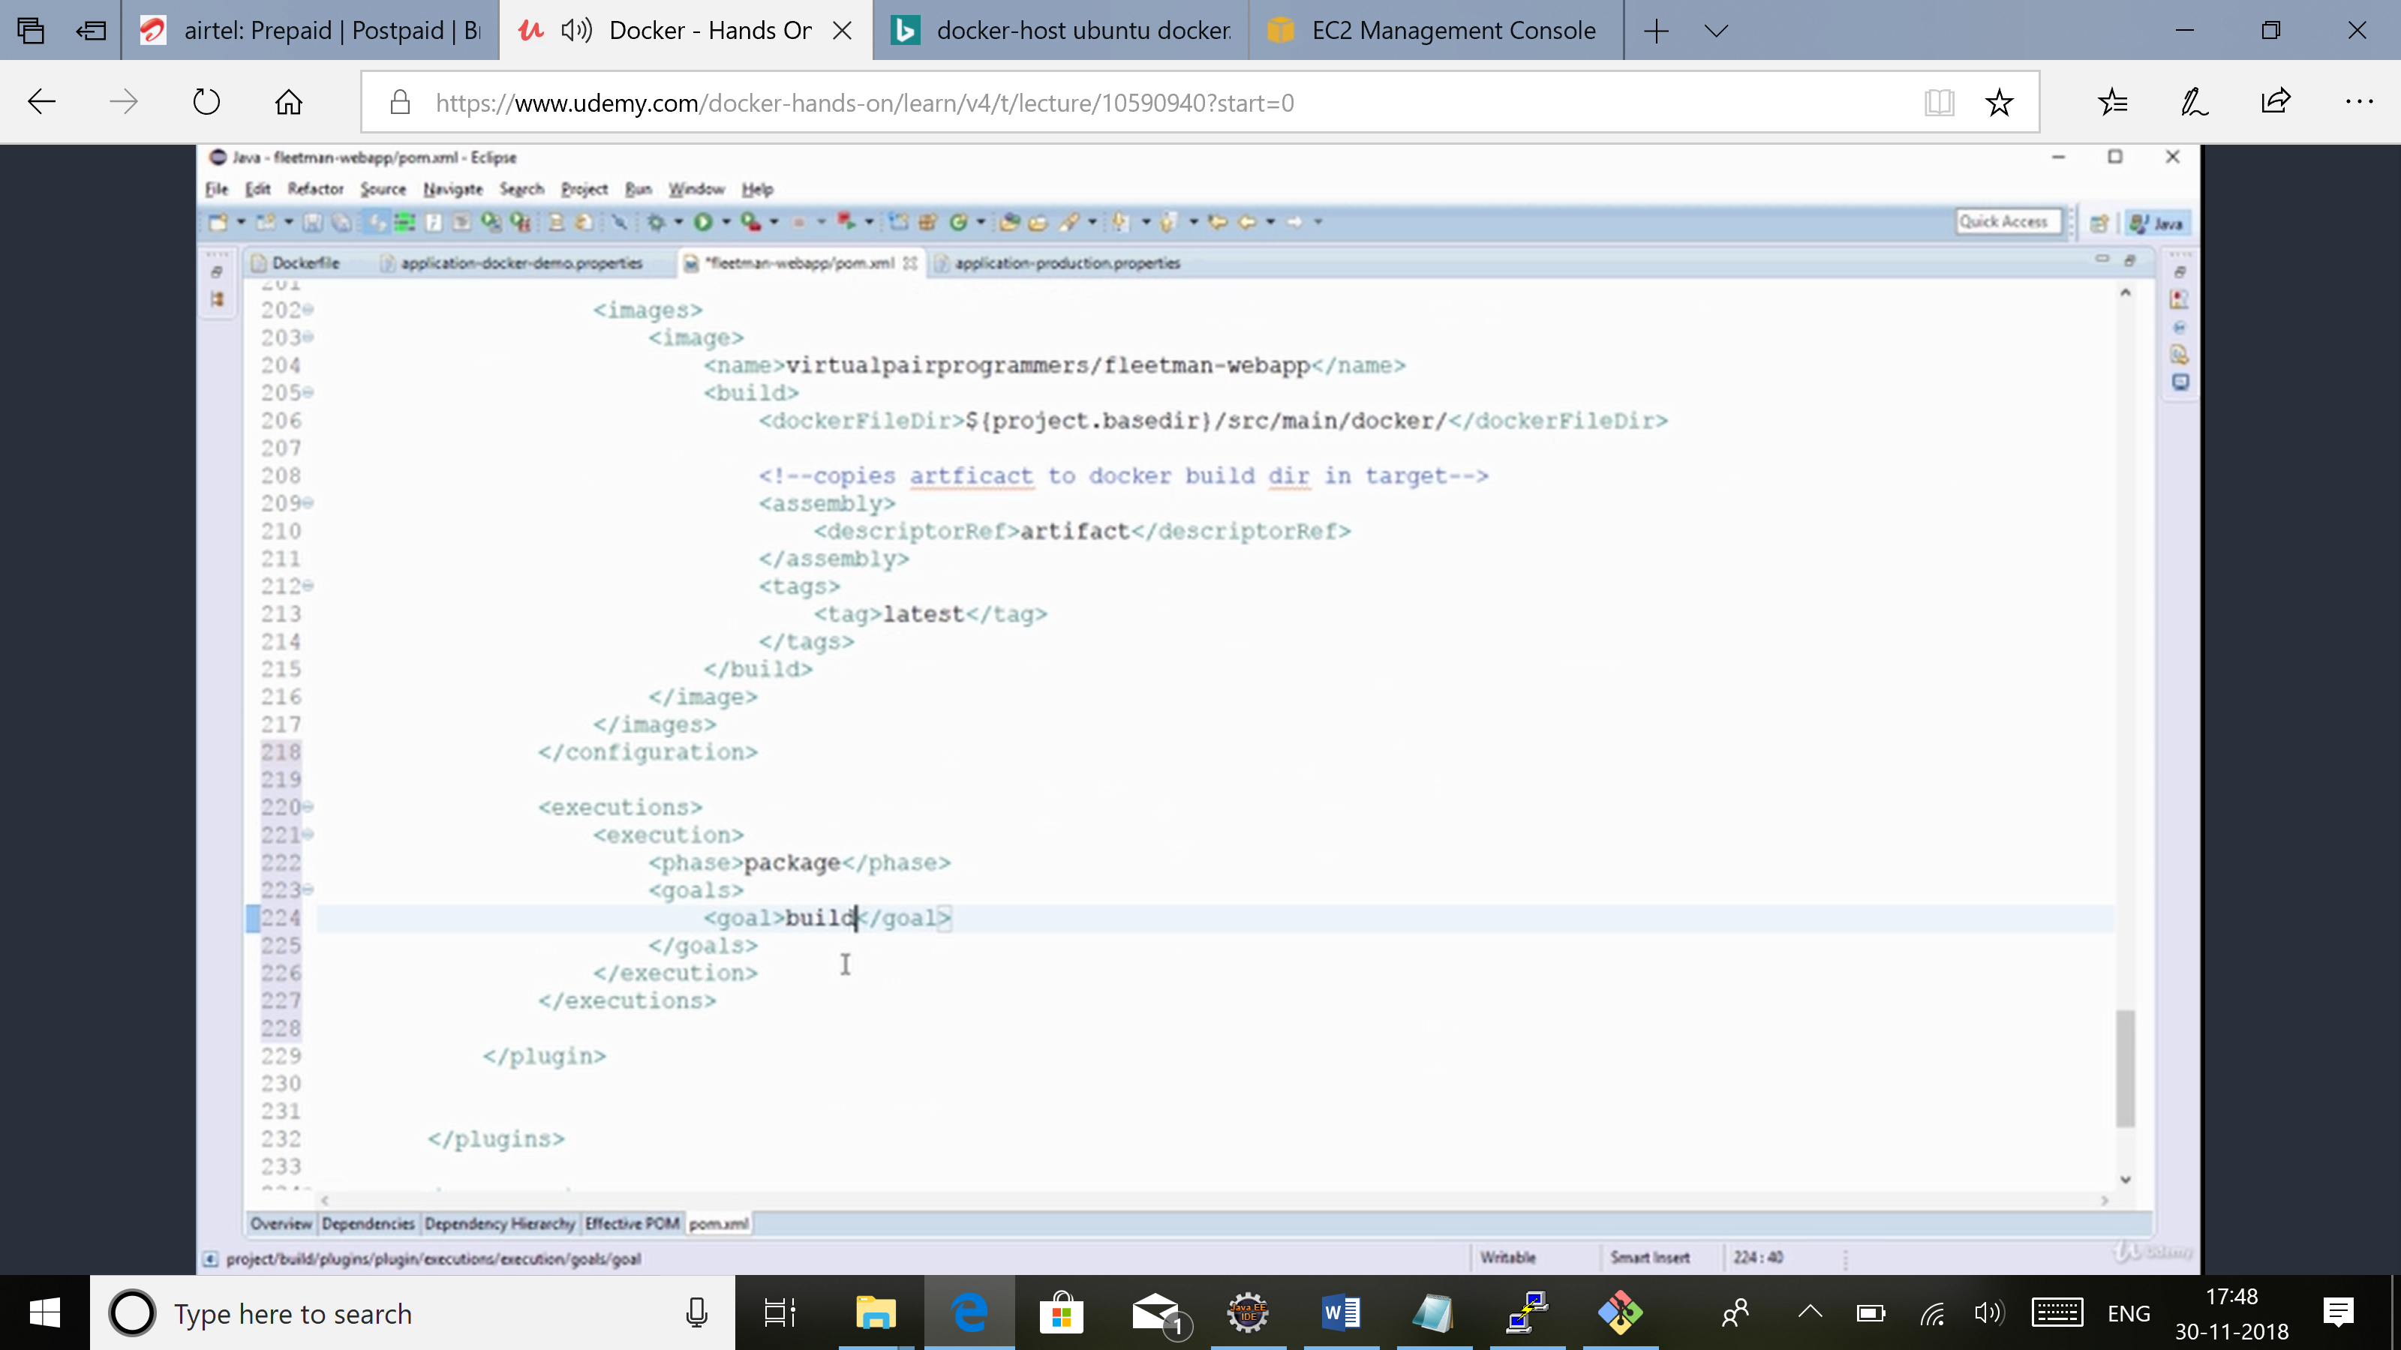

Build coming from docker plugin

Clean package docker:push

Docker swarm: for restarting containers on failure. Balancing system, can decide which system a container should run.

<https://labs.play-with-docker.com/>

docker swarm: to see available options

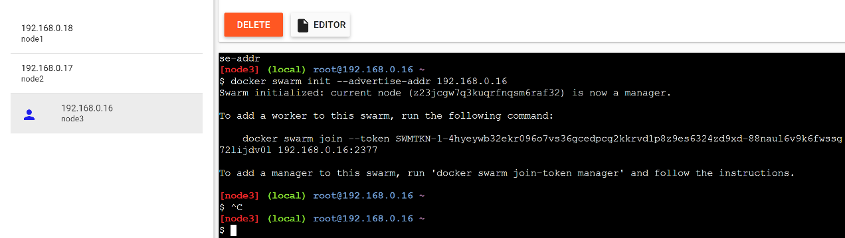

Now this computer is running in swarm mode.

This node is now a manager, so can add worker to a swarm using command given.

Instead of doing docker containr run..

Docker service create -d –network n1 -e MYSQL_ROOT_PASSWORD=password e MYSQL_ROOT_USER=username --name database mysql

-name: name of service

The network scoped to swarm can only be used. When working in swarm, we need network of type overlay as they will run on diff nodes.

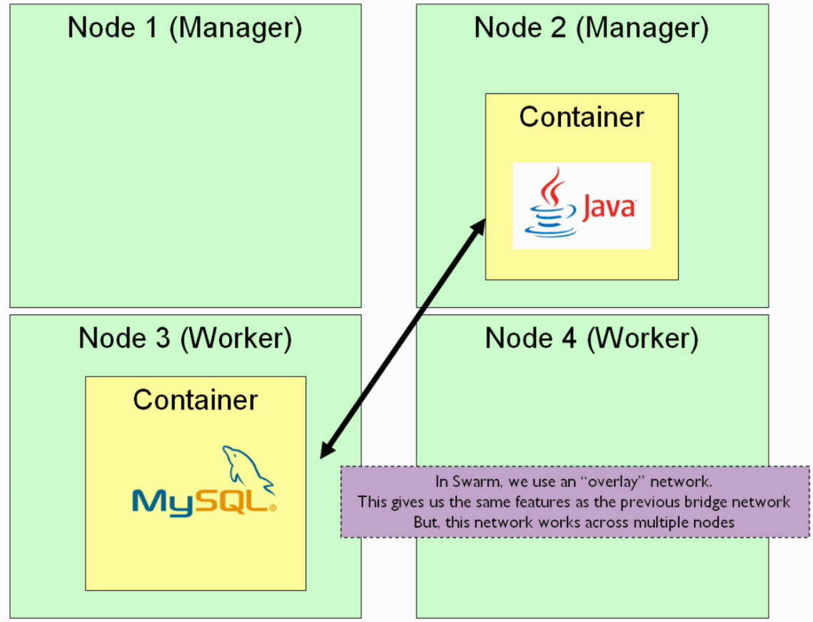

Docker network create --driver overlay n1

Docker network rm n2 : to remove network with name n2

Docker service ls: to see running services. It would be running containers internally.

If a service is running on a particular node, on that node can see by docker container ls.

I've discovered that labs.play-with-docker.com/ doesn't work if you have an adblocker installed - the "login" button won't respond. I don't think they're doing anything nasty, it's just a bug on the site.

Docker node ls : to see nodes

Docker swarm join-token manager|worker: to get token to add node as manager/worker

Some commands only work on manager node.

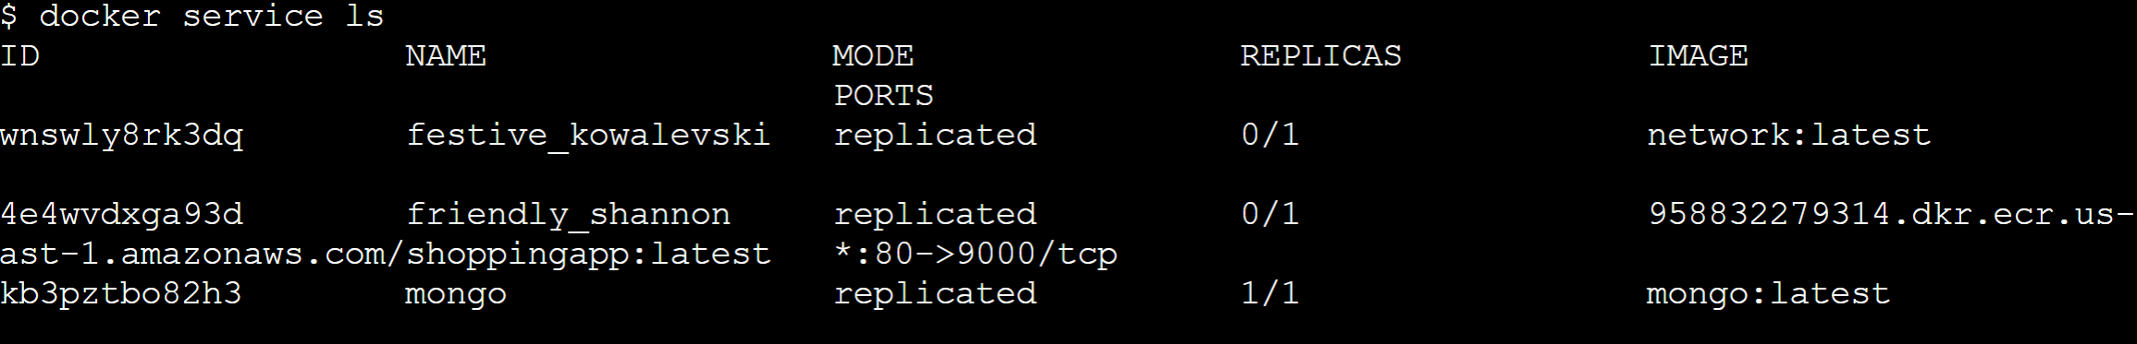

0/1: means not running.

To create nodes locally

Docker service logs -f mongo

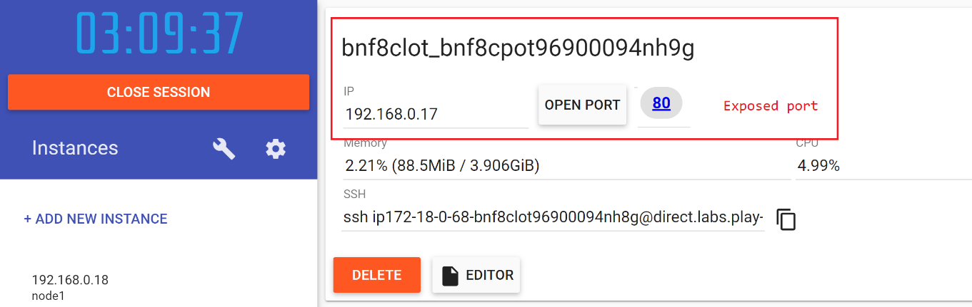

reate nodes

Shell



|  |  |
| --- | --- |
| 1  2  3  4  5  6  7  8  9 | $ docker-machine create master  $ docker-machine create worker-1  $ docker-machine create worker-2  Docker-machine ls  Docker-machine ssh master   docker swarm init --advertise-addr 192.168.99.100  docker-machine worker-1 \    ssh docker swarm join --token SWMTKN-1-2ok9r6uroyreyghfpkqlj42cninm63rzy4vifjiu9rzg8z0okv-7lu70r5goheti58bcr74m00zf 192.168.99.100:2377  # This node joined a swarm as a worker.    docker-machine ssh worker-2 \    docker swarm join --token SWMTKN-1-2ok9r6uroyreyghfpkqlj42cninm63rzy4vifjiu9rzg8z0okv-7lu70r5goheti58bcr74m00zf 192.168.99.100:2377  # This node joined a swarm as a worker.  # Deploy visualization service  docker service create \  --name=viz \  --publish=8080:8080 \  --constraint=node.role==manager \  --mount=type=bind,src=/var/run/docker.sock,dst=/var/run/docker.sock \  dockersamples/visualizer |

Automate deployment of services using stacks:

Both manager and worker will have containers deployed to them.

Manager: Can manage the swarm like docker service ls.

Worker:

Can make all nodes as managers. Uses raft system to communicate between managers. Work to keep managers in sync. If only 1 manager and it crashes, whole system useless.

Should have odd number of managers.

If 5 instances, 3 managers and 2 workers.

Sample docker-compose.yaml:

version: "3"

services:

shoppingapp:

image: 958832279314.dkr.ecr.us-east-1.amazonaws.com/shoppingapp

networks:

- n1

environment:

- spring.profiles.active=dev

ports:

- 80:9000

depends_on:

- mongo

mongo:

image: mongo

container_name: mongo_ctr

networks:

- n1

environment:

- MONGO_INITDB_DATABASE=levent

- MONGO_INITDB_ROOT_USERNAME=mongo

- MONGO_INITDB_ROOT_PASSWORD=mongo

volumes:

- ./init-mongo.js:/docker-entrypoint-initdb.d/init-mongo.js:ro

ports:

- '27017:27017'

networks:

n1:

When working in swarm, have stack i.e. a complete application. Can see docker stack ls.

|  |  |
| --- | --- |
| [docker stack deploy](https://docs.docker.com/engine/reference/commandline/stack_deploy/) | Deploy a new stack or update an existing stack |
| [docker stack ls](https://docs.docker.com/engine/reference/commandline/stack_ls/) | List stacks |
| [docker stack ps](https://docs.docker.com/engine/reference/commandline/stack_ps/) | List the tasks in the stack |
| [docker stack rm](https://docs.docker.com/engine/reference/commandline/stack_rm/) | Remove one or more stacks |
| [docker stack services](https://docs.docker.com/engine/reference/commandline/stack_services/) | List the services in the stack |

docker stack deploy --compose-file docker-compose.yml <name-of-stack>

docker stack deploy -c docker-compose.yml <name-of-stack>

network automatically created as overlay.. as in stack, default is overlay while running locally is bridge.

No particular sequence in which containers will start. By-default swarm will restart container if one crashes.

Docker service ps <service-name>: will show where service started.. if failed.. then which node it started again..

Docker service logs -f <service-name>

<https://docs.docker.com/compose/compose-file/>: configure compose file for stack

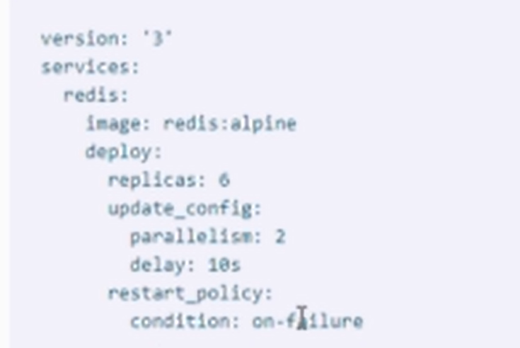

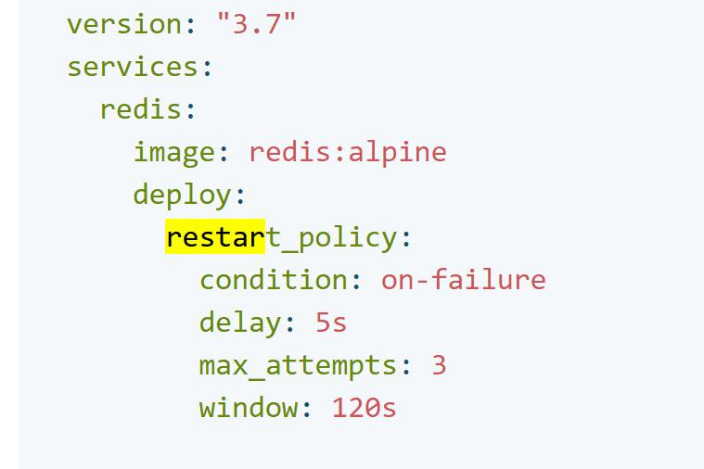

Restart: condition: any: will restart even if container exits successfully

Max_attempts: default: never give up

If running locally, deploy tag in docker-compose file will be ignored as it makes sense only for docker swarm.

Even if webapp running on one, automatically load balanced to the node on which service is running

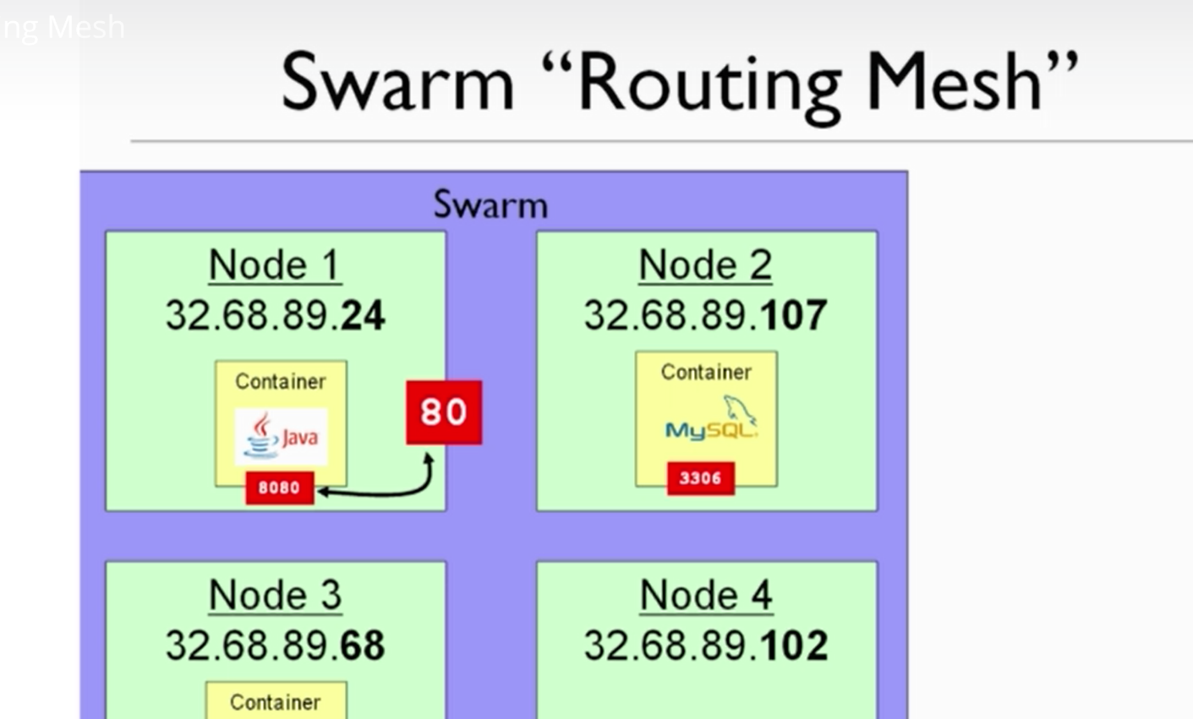

When request goes within the network, it is fine as port is visible within network.

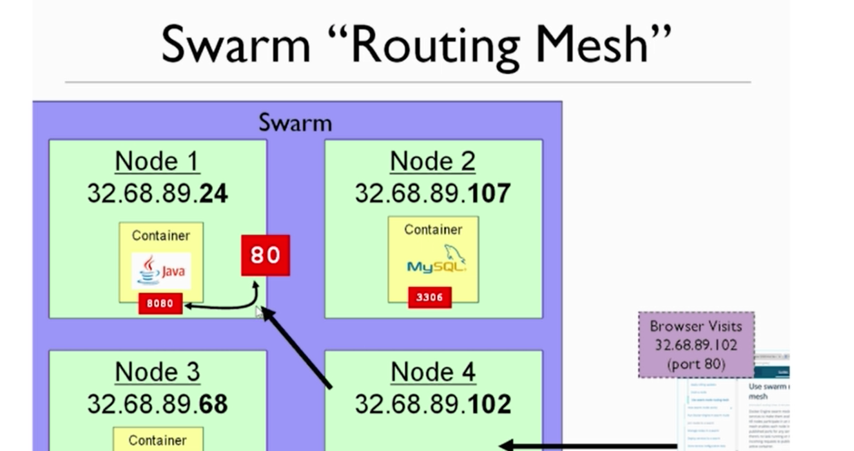

Request internally routed to node on which port 80 is exposed.

For routing mesh, need to open some ports

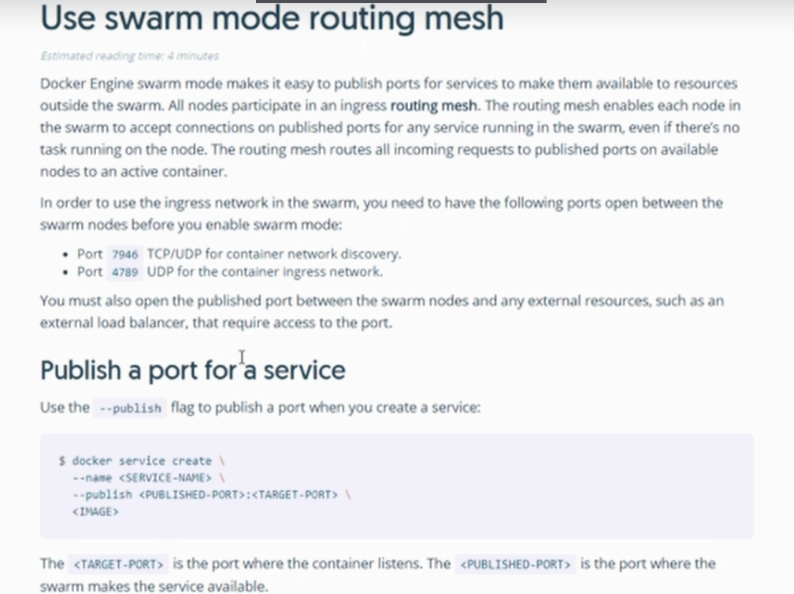

Docker-swarm-visualizer: a container. No need to add it to docker-compose. Not a service. Can publish this to any outside port.

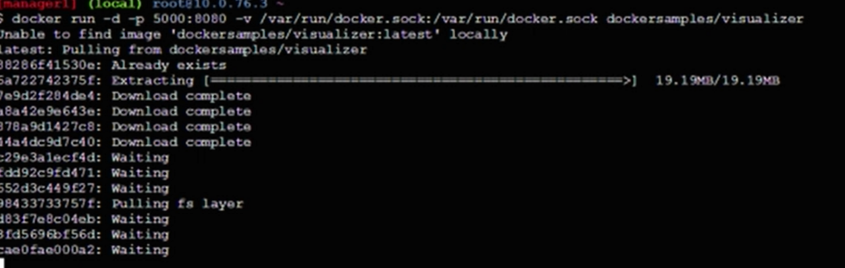

Same colors for replicas.

If one node crashes, will automatically restart

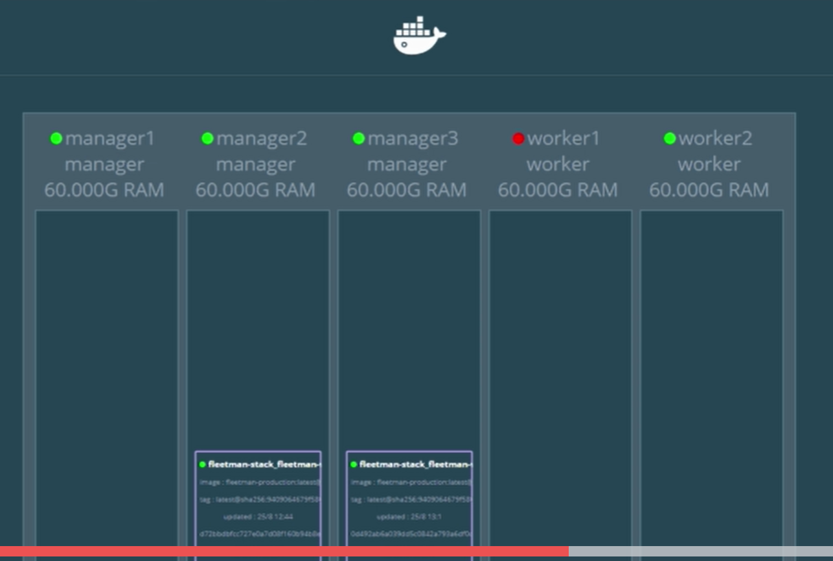

If pushing change to docker ..

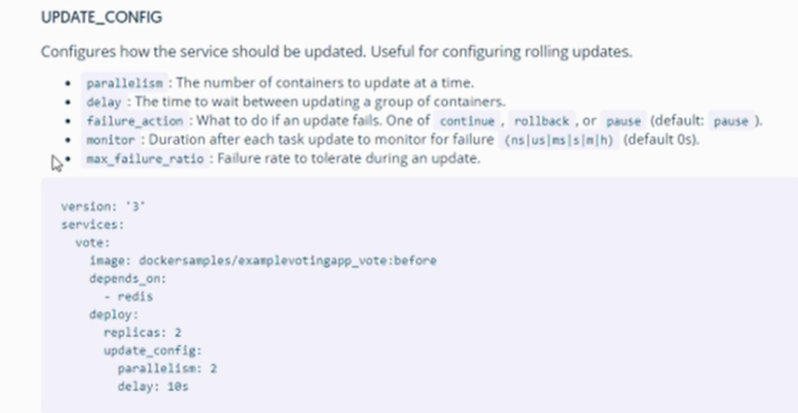

2 min delay in doing update.

To push those changes to stack:

Docker stack deploy should be run again. It will find images which have been updated and will update those. It may direct request to a container which is still starting. So may have short period of errors. Or may send request to old container. Docker cannot distinguish between healthy or not. So can use EC2 load balancer.

Spin up 3 instances on Elastic Beanstalk . Add key pair. Under **Elastic Beanstalk** > Configuration > Security, choose the new **key** from the EC2 **key pair** drop-down.

docker run -it -d -p 5000:8080 -v /var/run/docker.sock:/var/run/docker.sock dockersamples/visualizer

docker container stop: to stop a particular container.

In application decide on ports, container names, don’t change that. Only publish port for frontend, internally may be using any ports.